**Topics: Descriptive Statistics and Probability**

1. Look at the data given below. Plot the data, find the outliers and find out $μ, σ, σ^{2}$

|  |  |
| --- | --- |
| **Name of company** | **Measure X** |
| Allied Signal | 24.23% |
| Bankers Trust | 25.53% |
| General Mills | 25.41% |
| ITT Industries | 24.14% |
| J.P.Morgan& Co. | 29.62% |
| Lehman Brothers | 28.25% |
| Marriott | 25.81% |
| MCI | 24.39% |
| Merrill Lynch | 40.26% |
| Microsoft | 32.95% |
| Morgan Stanley | 91.36% |
| Sun Microsystems | 25.99% |
| Travelers | 39.42% |
| US Airways | 26.71% |
| Warner-Lambert | 35.00% |

**ANS: PLOTTING A GRAPH**

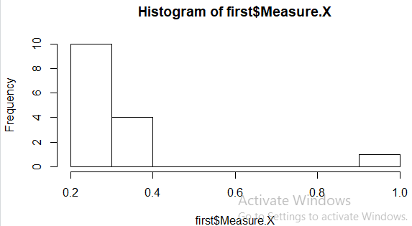

**OUTLIERS: Q1=0.1102 Q3=0.4938**

mean(first$Measure.X)==0.332

sd(first$Measure.X)==0.1685315

var(first$Measure.X)==0.02840286



Answer the following three questions based on the box-plot above.

1. What is inter-quartile range of this dataset? (please approximate the numbers) In one line, explain what this value implies.

**ANS:IQR=7 This value implies that most of the data points in this distribution lies in this range .**

1. What can we say about the skewness of this dataset?

**Data is right skewed.**

1. If it was found that the data point with the value 25 is actually 2.5, how would the new box-plot be affected?



Answer the following three questions based on the histogram above.

1. Where would the mode of this dataset lie?

**The mode of the dataset lies at 20 .This distribution has 2 peaks of the same height.**

1. Comment on the skewness of the dataset.

**It represents the right skewed distribution.**

1. Suppose that the above histogram and the box-plot in question 2 are plotted for the same dataset. Explain how these graphs complement each other in providing information about any dataset.

**Both the plots gives positively skewed data distribution and both have outliers at 25**

1. AT&T was running commercials in 1990 aimed at luring back customers who had switched to one of the other long-distance phone service providers. One such commercial shows a businessman trying to reach Phoenix and mistakenly getting Fiji, where a half-naked native on a beach responds incomprehensibly in Polynesian. When asked about this advertisement, AT&T admitted that the portrayed incident did not actually take place but added that this was an enactment of something that “could happen.” Suppose that one in 200 long-distance telephone calls is misdirected. What is the probability that at least one in five attempted telephone calls reaches the wrong number? (Assume independence of attempts.)

**ANS: probability of one wrong number out of 200 calls**

**P(WN) = 1/200 = 0.005**

**Probability of not wrong number: 1 - P(WN) =1- 1/200 = 0.995**

**Probability of at least one out of five is a wrong number**

**= 1 – (1 – P(WN))^5**

**= 1 – (1- 0.005)^5**

**= 1 – 0.975**

**= 0.024= 2.5%**

1. Returns on a certain business venture, to the nearest $1,000, are known to follow the following probability distribution

|  |  |
| --- | --- |
| x | P(x) |
| -2,000 | 0.1 |
| -1,000 | 0.1 |
| 0 | 0.2 |
| 1000 | 0.2 |
| 2000 | 0.3 |
| 3000 | 0.1 |

1. What is the most likely monetary outcome of the business venture?
2. Is the venture likely to be successful? Explain
3. What is the long-term average earning of business ventures of this kind? Explain
4. What is the good measure of the risk involved in a venture of this kind? Compute this measure